The Atrial Fibrillation Clinic at Northwest Community Healthcare

Atrial Fibrillation (AFib) is the most common heart arrhythmia (abnormal heart rhythm). It is caused by short circuits in the upper chamber of the heart (atria) that can cause a spectrum of symptoms, including palpitations (racing or irregular heart beat), chest discomfort, shortness of breath, and dizziness. Many people have no symptoms at all. In addition, AFib carries a higher risk of stroke and heart failure. Because of these risks most patients will be placed on medications to control their heart rates and may be recommended to start anticoagulation to help reduce the risk of stroke. All patients will be followed closely by their cardiologist and the Atrial Fibrillation Clinic, who work as a team to care for you.
Included in this packet is information about atrial fibrillation and recommendations to prevent the progression and complications associated with AFib. There are an array of treatment options for AFib, including medications, cardioversions and ablation procedures. Our goal is to provide comprehensive information and support in order for you to make the best decisions regarding your treatment of AFib.
Contact / Location
Atrial Fibrillation Clinic
199 W. Rand Rd.
Mount Prospect, IL 60056
847-618-2440

Appointments are available Mondays, Wednesdays and Fridays

WHAT IS ATRIAL FIBRILLATION?
Atrial fibrillation (also called AFib or AF) is a quivering or irregular heartbeat (arrhythmia) that can lead to blood clots, stroke, heart failure and other heart-related complications. At least 2.7 million Americans are living with AFib.

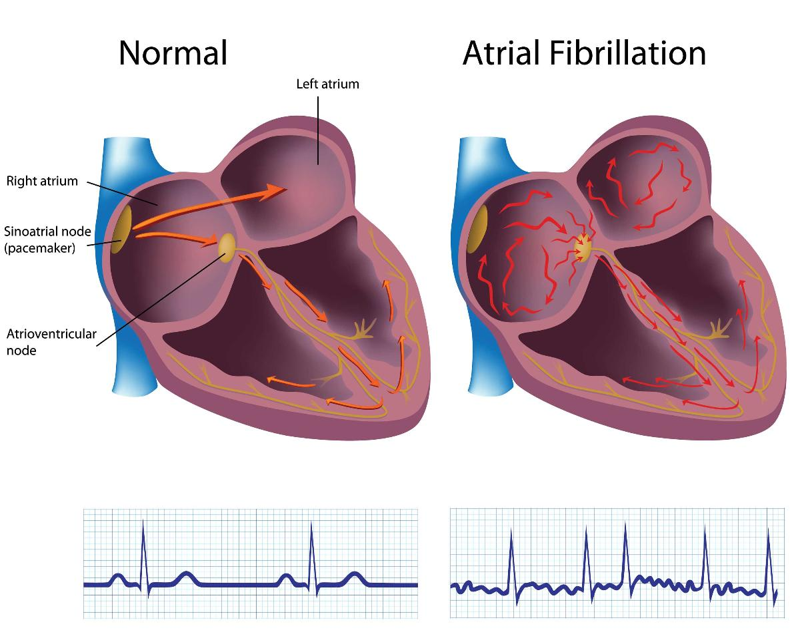

With atrial fibrillation, random electrical activity interrupts the normal conduction rhythm. This prevents the atria from properly contracting.

Normally, your heart contracts and relaxes to a regular beat. Certain cells in your heart make electric signals that cause the heart to contract and pump blood. These electrical signals show up on an electrocardiogram (ECG) recording. Your doctor can read your ECG to find out if the electric signals are normal.
In atrial fibrillation (AFib), the heart’s two small upper chambers (atria) don’t beat the way they should. Instead of beating in a normal pattern, the atria beat irregularly and too fast, quivering like a bowl of gelatin. It’s important for the heart to pump properly so your body gets the oxygen and food it needs.
WHAT ARE SYMPTOMS OF ATRIAL FIBRILLATION?

Sometimes people with AFib have no symptoms and their condition is only detectable upon physical examination. Still, others may experience one or more of the following symptoms:
- General fatigue
- Rapid and irregular heartbeat
- Fluttering or “thumping” in the chest
- Dizziness
- Shortness of breath and anxiety
- Weakness
- Faintness or confusion
- Fatigue when exercising
- Sweating
- Chest pain or pressure

ARE THERE DIFFERENT TYPES OF AFIB?
The symptoms are generally the same; however the duration of the AFib and underlying reasons for the condition help medical practitioners classify the type of Atrial Fibrillation.
- Paroxysmal fibrillation is when the heart returns to a normal rhythm on its own within 7 days of its start. People who have this type of AFib may have episodes only a few times a year or their symptoms may occur every day. These symptoms are very unpredictable and often progress to a more persistent or permanent form of atrial fibrillation.
- Persistent AFib is defined as an irregular rhythm that lasts for longer than 7 days. This type of atrial fibrillation will not return to normal sinus rhythm on its own and will require some form of treatment.
- Long-standing AFib is when the heart is consistently in an irregular rhythm that lasts longer than 12 months.
- Permanent/Chronic AFib occurs when the condition lasts indefinitely and the patient and doctor have decided not to continue further attempts to restore normal rhythm.
- Nonvalvular AFib is atrial fibrillation not caused by a heart valve issue.
Over a period of time, paroxysmal fibrillation may become more frequent and longer lasting, sometimes leading to permanent or chronic AFib. All types of AFib can increase your risk of stroke.
Even if you have no symptoms at all, you are nearly 5 times more likely to have a stroke than someone who doesn’t have atrial fibrillation.

WHO IS AT HIGH RISK FOR DEVELOPING AFIB?
Typically people who have one or more of the following conditions are at higher risk for AFib:
- Advanced age: The number of adults developing AFib increases markedly with older age.
- Sleep apnea: Although sleep apnea isn’t proven to cause AFib, studies show a strong link between obstructive sleep apnea and AFib. Often, treating the apnea can improve AFib.
- Obesity and Sedentary Lifestyles
- High blood pressure: Longstanding, uncontrolled high blood pressure can increase your risk for AFib.
- Underlying heart disease: Anyone with heart disease, including valve problems, hypertrophic cardiomyopathy, acute coronary syndrome, Wolff-Parkinson-White (WPW) syndrome and history of heart attack. Additionally, atrial fibrillation is the most common complication after heart surgery.
- Drinking Alcohol: Consistently high alcohol use and binge drinking may put you at higher risk for AFib.
- Family history: Having a family member with AFib increases your chances of being diagnosed.
- Athletes: AFib is common in athletes and can be triggered by a rapid heart rate called a supraventricular tachycardia (SVT).
- Other chronic conditions: Others at risk are people with thyroid problems (specifically hyperthyroidism), diabetes, asthma and other chronic medical problems.

WHAT ARE THE CONSEQUENCES OF AFIB?
Although atrial fibrillation can feel weird and frightening, an “attack of AFib” usually doesn’t have harmful consequences by itself. The real danger is the increased risk for stroke and heart failure. Even when symptoms are not noticeable, AFib can increase a person’s risks for stroke and related heart problems.

HOW DOES AFIB LEAD TO A STROKE?
- The heartbeat seems to quiver (or fibrillate) in an erratic way. The upper chambers (the atria) of the heart do not produce an effective, regular contraction, but contract irregularly.
- The contraction fails. When a heart contraction is either too fast or too uneven, it doesn’t completely squeeze the blood from the atria into the next chamber.
- Blood pools in the atria. Blood not completely pumped out of the atria can remain and may pool there.
- Risks of clotting go up. When blood has the opportunity to pool, it also has the opportunity to clot.
- Clots can travel and cause blockages. If a blood clot forms in the atria, it can be pumped out of the heart to the brain, blocking off the blood supply to an artery in the brain, causing a stroke. This type of stroke is called an embolic stroke or some doctors call it a cardioembolic stroke.

People with AFib are 5 times more likely to have a stroke!

HOW DOES AFIB LEAD TO HEART FAILURE?
Heart failure means the heart isn’t pumping enough blood to meet the body's needs. AFib can lead to heart failure because the heart is beating so fast that it never properly fills up with blood to pump out to the body.
As a result, when the heart doesn't efficiently pump the blood forward with strong contractions, symptoms develop because:
- Blood can “back up" in the pulmonary veins (the vessels that return oxygen-rich blood from the lungs to the heart.) which can cause fluid to back up into the lungs.
- When AFib causes heart failure, fluid in the lungs can cause fatigue and shortness of breath. Oxygen-rich blood is not being delivered to the body and brain, causing physical and mental fatigue and reduced stamina. Fluid also can build up in the feet, ankles, and legs, causing heart-failure related weight gain.

People with AFib are 3 times more likely to develop heart failure!

GOALS OF TREATMENT:
Although no one is able to absolutely guarantee that a stroke or a clot can be preventable, there are ways to reduce risks for developing these problems. After a patient is diagnosed with atrial fibrillation, the ideal goals may include:
- Reducing an overly high heart rate (called rate control)
- Restoring the heart to a normal rhythm (called rhythm control)
- Preventing blood clots (called prevention of thromboembolism,such as stroke)
- Managing risk factors – weight loss, exercise, alcohol reduction, sleep apnea evaluation and treatment
- Preventing additional heart rhythm problems
- Preventing heart failure
TREATMENT OPTIONS FOR AFIB:

The severity, any other underlying medical issues you might have, and the length of time you have had AFib will determine the best treatment options for you. In addition to knowing your goals, you will want to discuss your treatment options and take an active role in your plan.
Medications: there are two strategies with medications that are typically used to treat atrial fibrillation. You will want to discuss with your provider which medical therapy is right for you.
- The first are used to slow or control fast heart rates associated with AFib, as this can cause symptoms and progression into heart failure. There are three primary classes of medications, including beta-blockers, calcium channel blockers and digoxin.
- The other treatment aims to keep you out of atrial fibrillation and maintain a normal heart rhythm. These are called anti-arrhythmic agents. You may have to have additional diagnostic testing prior to starting this type of medication.
- Additionally, many patients are recommended to start anticoagulation medications that thin the blood to reduce the risk of embolic stroke.
Cardioversion: An outpatient procedure done at the hospital that attempts to reset your heart rhythm from atrial fibrillation back to a normal rhythm. This is done under conscious sedation and involves a therapeutic dose of electric current to your chest. You will remain on medications before and after a cardioversion.

TREATMENT OPTIONS FOR AFIB (CONT):

Cardiac Ablation: This is a medical procedure that is performed in the Electrophysiology Lab in the hospital. An ablation procedure involves identifying and localizing cardiac tissue where AFib originates and creating scars with either radiofrequency or cryoblation therapies to isolate the abnormal electrical activity. Catheters are inserted into a vein in the upper leg or neck and are advanced to the heart using fluoroscopy (or x-rays). The catheters record electrical signals from inside the heart and attempt to precisely locate the site of the atrial fibrillation. 3-dimensional mapping systems are often needed to precisely localize the abnormal site or activity and allow for a lower dose of x-ray exposure. Energy is delivered by the catheter to the location responsible for generating AFib, creating a small lesion. This technique is used to maintain normal rhythm. Your electrophysiologist will discuss which option is best for you if indicated. You will most likely stay overnight for observation after this procedure.
Additional Patient Resources:
Stop Atrial Fibrillation:
http://www.stopafib.org/

American Heart Association: http://www.heart.org/HEARTORG/Conditions/Arrhythmia/AboutArrhythmia/AFib-Resources-For-Patients Professionals_UCM_423786_Article.jsp#.WRCroTJ1odU

Heart Rhythm Society:
http://www.hrsonline.org/Patient-Resources/Heart-Diseases-Disorders/Atrial-Fibrillation-AFib

STROKE WARNING SIGNS:

Spot a stroke F.A.S.T.:
- Face Drooping: Does one side of the face droop or is it numb? Ask the person to smile.
- Arm Weakness: Is one arm weak or numb? Ask the person to raise both arms. Does one arm drift downward?
- Speech Difficulty: Is speech slurred, are they unable to speak, or are they hard to understand? Ask the person to repeat a simple sentence, like "the sky is blue." Is the sentence repeated correctly?
- Time to call 9-1-1: If the person shows any of these symptoms, even if the symptoms go away, call 9-1-1 and get them to the hospital immediately.

