If you have any problem with registration or with the program, please contact: Lifelong Learning Help desk at 1-888-242-2453 or email at learn@heart.org
NOTE: YOU MUST claim credit at the for Part 1 and Part 2 to be considered COMPLETE. If credit is not claimed at the end of Part 2, you will not be on IQVIA’s pass list!
If you need assistance preparing for the exam please contact your local AHA Quality Improvement Director. If you do not know which area to select, please contact Stacia Hickey at Stacia.Hickey@heart.org for further assistance.

BEFORE YOU BEGIN
- You must use Chrome as your browser for the Part 1 practice test and Part 2 certification exam. Internet Explorer will not display all the test questions.
- This testing platform contains pop-up windows. Please adjust your internet browser settings to allow for pop-up windows while taking this exam.
- Please make sure your contact information in your user record is up to date on https://professional.heart.org
  - You can access your user record by login into the Professional Education website, then click on ‘Dashboard’ under your name in the top right corner of the page. Then under ‘Links’ select ‘Profile Update’

REGISTRATION
- Start at our Professional Education website https://professional.heart.org
- In the top right corner click on “SIGN IN” and enter your login information
  - If this is your first time using the Professional Education website, you will need to create an account. Please follow the instructions on screen to do so.
- Once logged in, click on the EDUCATION & MEETINGS menu
- Select the first option, “Education & Meetings”
- Scroll down the page and click on ‘Online Courses’
- In the search bar at the top of the page type ‘2019 Part 1’ and hit enter.
- Click on the Register button for the ‘2019 Part 1 - Get with the Guidelines-Resuscitation Data Abstractor Training and Certification Program’
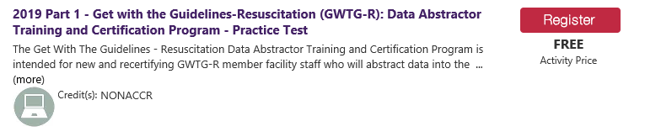

TAKING PART 1 - Get with the Guidelines-Resuscitation Data Abstractor Training and Certification Program
Note: This is a practice test and you will receive a passed score even if you did not mark the questions correct. You should review your answers to see your actual results.
- To take the test you must follow the tabs from left to right and complete all sections. The system will provide prompts as you progress and will require completion of one tab before allowing access to the next one. The first tab requires that you check a box that you have read the content.
- Watch the Abstractor Training Webinars Part 1 and Part 2. Review the Coding Instructions located as a download in the Patient Management Tool (PMT). If you do not have access to the PMT then contact your local AHA Quality Improvement Director and request a copy.
- The test itself is located on the Post-Assessment tab. Click the ‘Launch’ button to access the test.
- Once you start the test you have an option to “Save and Finish Later”.
  - If you save the test, you can come back later to where you stopped. The test will show as “In Progress” in the “Post-Assessment” tab.
  - After you complete the Part 1 Practice Test the button to the right will change to read as “VIEW”
- Once you submit the Practice Test, a window will open with your test, the answers you chose and indications of “Correct” or “Incorrect” noted below each question. You can print the exam with your answers. Once you close your graded test window, your browser will redirect back to the “Post Assessment” Tab.
- Click on the “Launch” button next to “NEXT STEPS”.
- A new window will open. Click on the blue text reading “Click here leading to your next steps in the certification and the practice test rationale.”
- A window will open to a page on heart.org where you can see, download and review:
  - Practice Test with answers and rationale
  - Training resources
  - Additional important information including the Access code to take the Part 2 – Certification Exam.
MAKE A NOTE OF THE ACCESS CODE. You must have this code to access the certification exam.

- After reviewing next steps, return to the pop-up window and click on ‘SUBMIT’
- Click on the Claim Credit Tab and click “CLAIM CREDIT’
Note: The Part 1 is required but is only half of the Get with the Guidelines-Resuscitation (GWTG-R): Data Abstractor Training and Certification Program. You must take and pass the Part 2 to complete the activity and be considered certified.
- Click on the CERTIFICATE TAB and click “CLOSE” to exit Part 1. You do not receive continuing education credit for Part 1, but you can print your certificate of completion from this tab by clicking on the blue link that reads “NONACCR ”

TAKING PART 2 - Get with the Guidelines-Resuscitation Data Abstractor Training and Certification Program
- In the search bar at the top of the page type ‘2019 Part 2” and hit enter.
- Click on the Register button for the ‘2019 Part 2 - Get with the Guidelines-Resuscitation Data Abstractor Training and Certification Program’
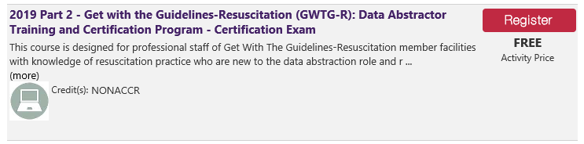

- The next screen will have you enter the access code from the “NEXT STEPS” page as is referenced in the instructions for the Part 1 Exam.
  - For convenience the code is: gwtgcertification
- On the next screen you will see five tabs. Read each section carefully and follow the listed instructions.
- ACTIVITY OVERVIEW TAB - Read the instructions and then click the checkbox at the bottom that reads “Please click here to confirm you have read the above information.”
- Click “CONTINUE”
- ACTIVITY MATERIAL TAB – you have the option to print the scenarios used for the exam from this tab. This will allow you to review the scenarios carefully prior to accessing the exam.
- Click “CONTINUE”
- POST ASSESSMENT TAB - Click on launch when you are ready to access the exam. You can save the exam and finish later if you need to. When you launch the exam again, you will return to where you left off and continue that same test attempt. If you submit the exam that will count as one of your three attempts.
- Once you submit the exam, a window will open with your exam, the answers you chose and indications of “Correct” or “Incorrect” noted below each question. You can print the exam with your answers. Once you close your graded exam window, your browser will redirect back to the “Post Assessment” Tab.
Note: You pass the exam with a score of 88% or better (3 missed questions). We recommend setting a time with your local AHA Quality Improvement Director if you need additional help preparing for this exam. If you do not know which area to select, please contact Stacia Hickey at Stacia.Hickey@heart.org for further assistance.
- Click on “LAUNCH” when you are ready to attempt the exam again.
- When you have successfully passed the exam, you will see a new line on the Post-Assessment tab reading “Steps to Begin Data Abstraction”. Click the “LAUNCH” button to the right. A pop-up window will open.
- Click on the text that reads “Please click to follow steps for you to begin data abstraction now that you are newly certified.”
- A window will open on heart.org with instructions on how to contact IQVIA and obtain your username and password for the Patient Management Tool.
- When you have completed reading the data abstraction next steps, return to the pop-up window and click SUBMIT.
- Click “CONTINUE” on the Post-Assessment Tab
- CLAIM CREDIT TAB – On this tab, click the button that says “CLAIMED” to claim your credit. Once you have done so, the button will turn grey as pictured below.
NOTE: YOU MUST claim credit for the exam, or the exam is NOT COMPLETE. If credit is not claimed, you have not finished the exam process.
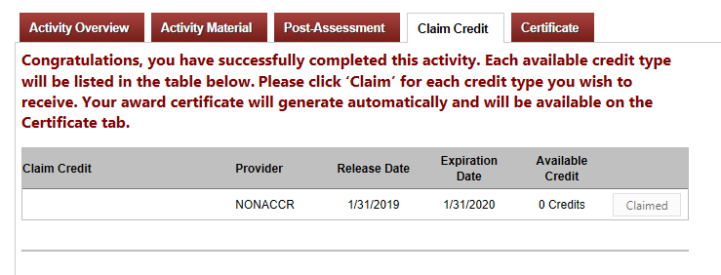
- Click “CONTINUE”
- CERTIFICATE TAB- Prior to closing out of the testing site make sure to download and save your certificate of completion for your records.
- Click on the blue link that reads “NONACCR”. In Chrome, you will see the file downloading at the bottom of your browser. Open and save the file for your records.
- To conclude the exam process, click “CLOSE”

OBTAINING YOUR PMT ACCESS AFTER PASSING THE EXAM
- The AHA will receive a report 1-2 working days after you pass your exam which reflects your “passed” status. IQVIA will be notified by AHA that you have completed the exam and are eligible to attend the PMT training and obtain your username and password.
- You will need to call IQVIA Help Desk 1-888-526-6700 to schedule your training.
- Please allow 3 business days after you pass your exam prior to contacting the help desk to ensure all the appropriate notifications have occurred.

AUTHORIZING ABSTRACTORS TO ENTER DATA
For IQVIA to provide access to the Patient Management Tool, they must have an email authorization from the Get with the Guidelines-Resuscitation lead at your hospital stating that you are permitted to enter data for the hospital.
If you are the Resuscitation lead, you will still send the email but note that you are the lead for the program at your hospital, that you will be entering data and that you will be authorizing other abstractors to enter data for the hospital.
Send the email to InfosarioOutcomeSupport@quintiles.com with the subject: “GWTG-R Data Abstractor Authorization”

