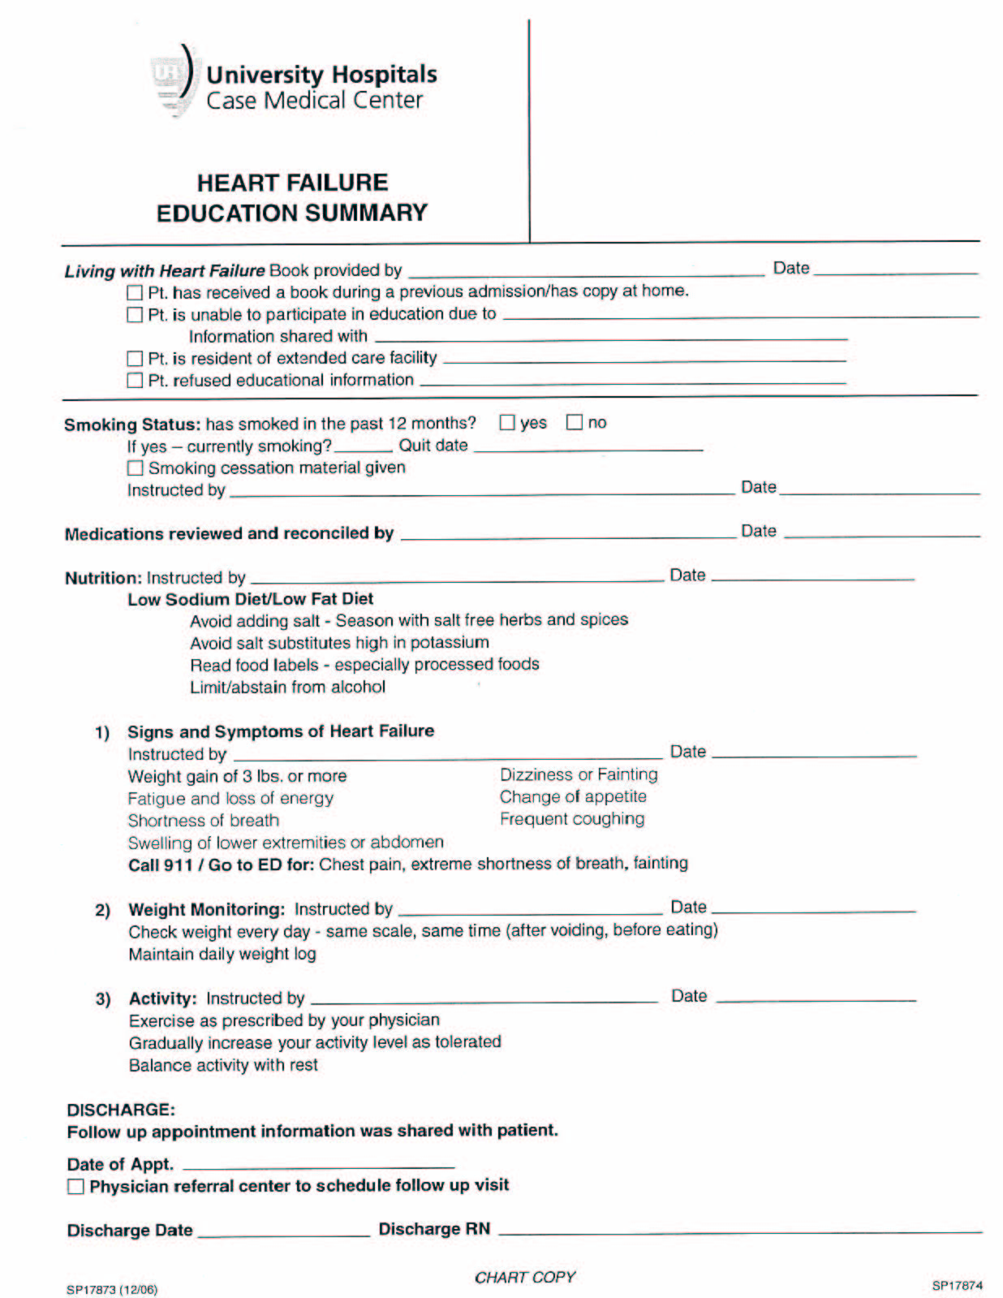

The Discharge education sheet is printed on pink paper for easy identification and placed in the front of the bedside chart of every identified HF patient along with a copy of the “Living with Heart Failure” booklet. The education sheet was introduced in early 2005 and revised in December of 2006.

