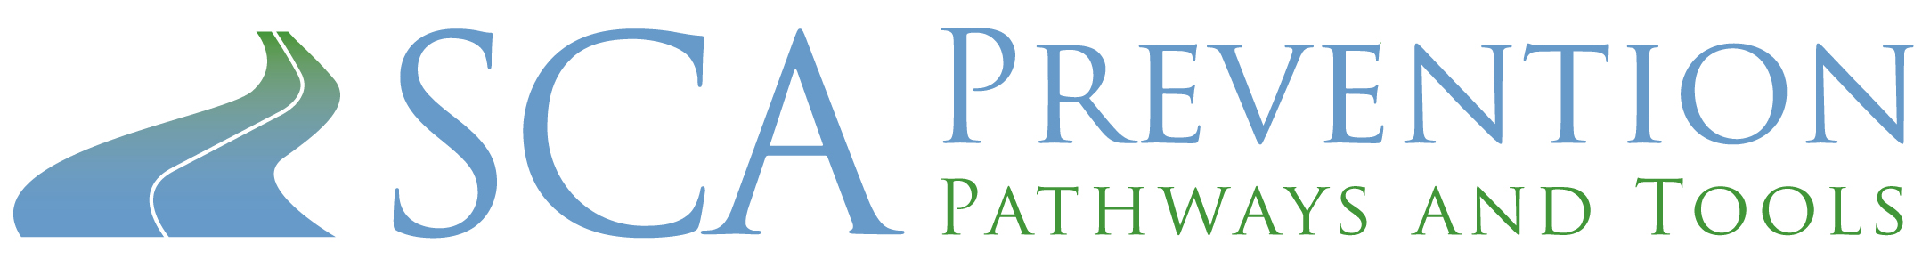

What Is Sudden Cardiac Arrest?

Normal heart rhythms are usually regular (the heart beats steadily and evenly). Sudden Cardiac Arrest (SCA) occurs when the lower chambers of your heart start beating very fast, weakly, and abnormally, preventing the heart from pumping blood to the body and brain. If SCA is not treated, it can lead to death within minutes.

In most cases, SCA occurs without warning and without symptoms. In some cases, SCA may begin with a decrease in blood flow to the heart or a heart attack. In other cases, SCA may be due to other causes and cardiac conditions. SCA can happen at any time – at home, at work, or when you are out doing your daily activities. People who experience SCA may lose consciousness before they even know what has happened or before they can ask for help.

How Does SCA Differ from a Heart Attack?
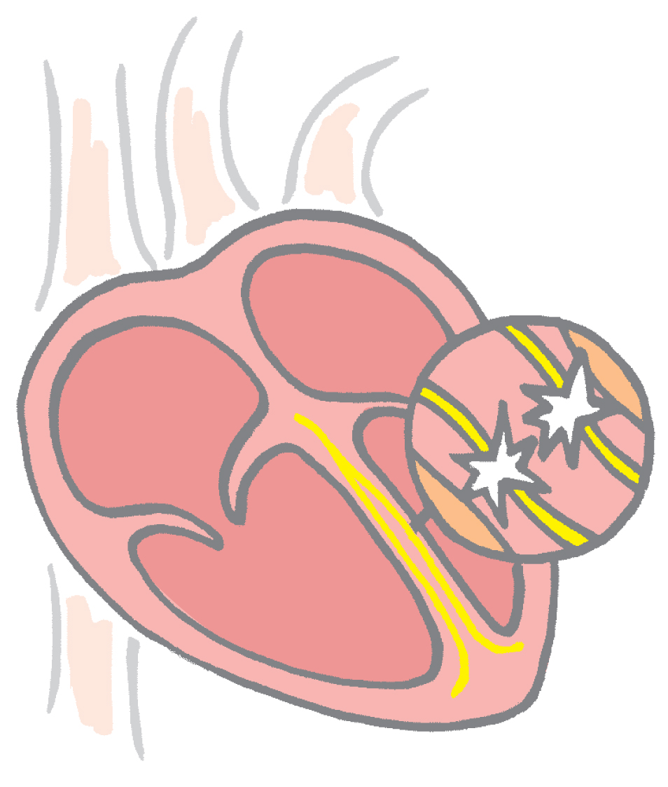
SCA is not a heart attack. A heart attack, or myocardial infarction (MI),
means an area of your heart muscle has been injured and has died.
A heart attack occurs when a heart muscle is damaged because it does
not get enough blood. Blood vessels, called coronary arteries, supply
blood and oxygen to the heart muscle. If one or more of the coronary
arteries become fully blocked, the heart muscle cannot get the oxygen
it needs, and the heart muscle may be permanently damaged. Think of
a heart attack as a plumbing problem in the heart.

In contrast, think of SCA as an electrical problem in the heart. The heart’s
pumping mechanism is powered by electrical signals. During SCA, the
heart’s electrical system works abnormally, leading to an irregular, abnormal
heartbeat. The abnormal heartbeat causes the heart muscle to quiver rather
than pump blood, and blood is not pumped to the body and brain.

The good news is that, today, doctors and nurses understand more about SCA and heart attacks, and have better ways to prevent them. There are medicines and treatments available to help avoid these events and potentially help people live normal lives.

Developed by the SCA Prevention Medical Advisory Team.
This material is intended to be educational. It is not intended to replace the information provided to you by your healthcare providers
and may not be directly applicable for your individual clinical circumstance.
Please refer to the manufacturers’ prescribing information and/or instructions for use for the indications, contraindications,
warnings, and precautions associated with the medications and devices referenced in these materials.

Sponsored by Medtronic, Inc.
May 2007
UC200705529 EN

