

What Are Arrhythmias?

Many people have questions about what the word “arrhythmia” means, and arrhythmias can be a difficult subject to understand. The text below should give you a better understanding of what arrhythmias are and the different types of arrhythmias that occur.

Normally the heart beats in a regular way – like a clock. However, many people, especially those with heart failure, have heart rates that are too fast, too slow, or irregular. These abnormal heart rhythms are referred to as arrhythmias. Some arrhythmias are harmless; however, some arrhythmias can be serious and even lead to Sudden Cardiac Arrest and death. Sometimes arrhythmias can cause symptoms such as heart palpitations (a racing heart or a pounding feeling), lightheadedness, or they may occur without any symptoms at all.

Although some arrhythmias do not require specific treatment, there are several ways to decrease, prevent, or treat arrhythmias. Treatments include medication, surgery, and the use of a device such as a pacemaker or an implantable defibrillator.

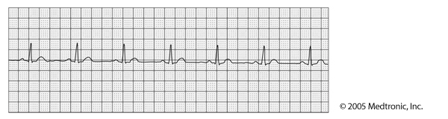
lower chamber
upper chamber

In a normal EKG, there are regular signals in both the upper and lower heart chambers.

Understanding Why Arrhythmias Occur
An arrhythmia can happen when any part of the heart’s electrical system is not normal. An arrhythmia can be thought of as an electrical problem, or short circuit, in the heart.

In contrast, a heart attack occurs when one or more of the arteries supplying the heart is suddenly clogged or blocked. A heart attack can be thought of as a plumbing problem in the heart.

So, even if a plumbing problem (for example, a blocked coronary artery) has been fixed, an electrical problem or arrhythmia can still develop. Likewise, electrical problems can exist even if there has never been a plumbing problem.

If the heart is enlarged and the muscle has been damaged, the electrical system may become irritated, increasing the risk of developing an arrhythmia.

Common Arrhythmias
Atrial Fibrillation
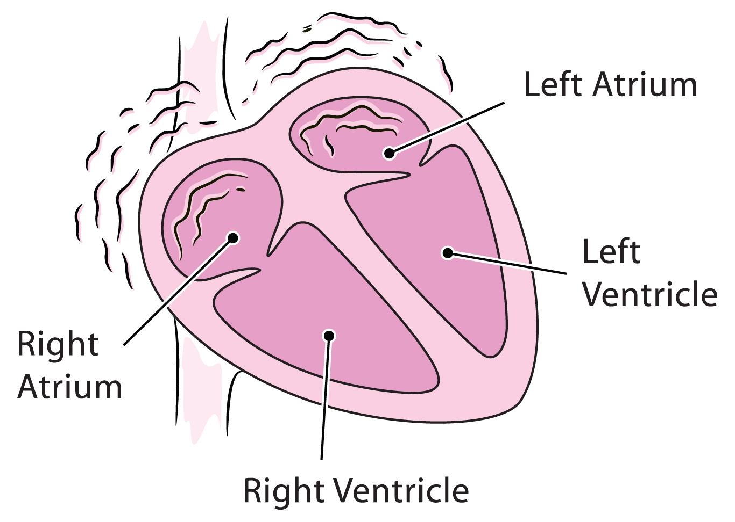
Atrial fibrillation (atrial = upper heart chambers,
fibrillation = quivering heartbeat) is common in
patients with high blood pressure and heart disease,
but is also found in patients with no heart disease at all.
It occurs most commonly in the elderly.

Atrial fibrillation is a very fast and irregular heartbeat
in the upper chambers of the heart (the atria). Instead
of a single signal creating a normal beat, the atria
quiver or fibrillate. If too many signals from the upper
chambers travel to the lower chambers (ventricles),
the ventricles will beat too quickly. It is important that
atrial fibrillation is diagnosed and treated promptly to avoid complications such as stroke, heart attack, and heart failure. Stroke can occur because the atria (upper chambers of the heart) do
not beat normally and blood moves slowly. Blood clots can form and travel to the brain, causing
a stroke.
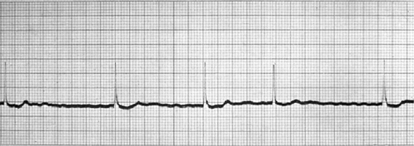

During atrial fibrillation, the upper chamber In a normal EKG, there are regular signals
signals are fast and irregular. in both the upper and lower heart chambers.

Some people experience palpitations, or they feel dizzy, lightheaded, short of breath, or fatigued. Other people live with atrial fibrillation but do not have any symptoms.

Treatment options for atrial fibrillation include:
Anticoagulants (blood thinners) – anticoagulants (most commonly warfarin) help reduce the chance of blood clots forming and reduce the chance of stroke. When warfarin is used, regular scheduled blood tests are needed to check that the dose is safe. Some people may be treated with aspirin instead of warfarin and some may not need blood-thinning at all.

Antiarrhythmic medicines – these are referred to as rhythm-control medicines. They attempt to maintain or restore normal heart rhythm. As with any medication, there are benefits and risks associated with use. Please discuss this with your doctor so that the complete prescribing information can be provided.

Rate-control medicines – medicines to control heart rate and prevent the heart from beating
too fast. Please discuss this with your doctor so that the complete prescribing information can
be provided.

Cardioversion – a normal heart rhythm can also be restored electrically through a procedure called cardioversion. A brief electrical shock is delivered to the heart to stop atrial fibrillation and restore a normal rhythm. This procedure is performed using short-term anesthesia. See additional safety information for ICDs.*

Ablation – a procedure called radiofrequency ablation is recommended to treat atrial fibrillation when it cannot be controlled with medicines alone. During this procedure, small thin wires are threaded into the heart and electrical energy is used to remove or ablate the tissues causing heart rhythm problems. There are benefits and risks associated with this procedure. Please ask your doctor to provide you with this information.

Surgery – a surgical procedure that involves making a series of cuts in the atria can be successful in treating atrial fibrillation. This procedure can require open-heart surgery and is most often done if other heart surgery is needed. As with any surgical procedure, there are benefits as well as risks. Talk to your doctor about this type of surgery to determine whether it is right for you and the associated risks.

Ventricular Tachycardia and Ventricular Fibrillation
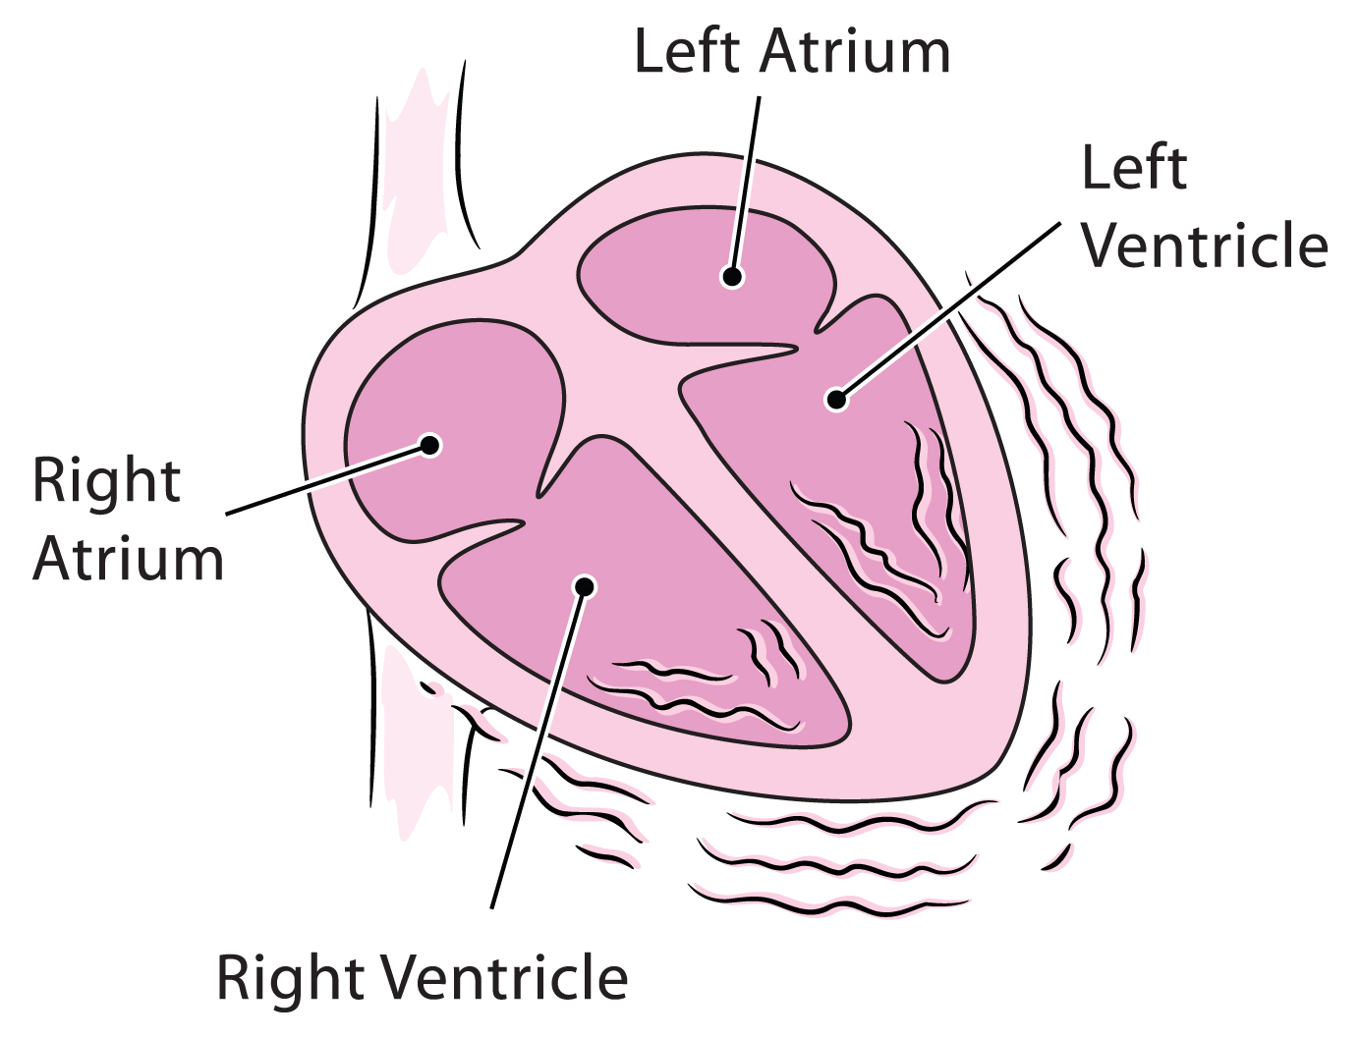
Ventricular tachycardia (ventricular = lower heart
chambers, tachycardia = fast heartbeat) is a rapid heart
rhythm that begins in the lower chambers of the heart
(ventricles). During ventricular tachycardia, the lower
chambers of the heart beat extremely fast. When the
ventricles beat too fast, the heart cannot fill with blood
or pump effectively. Some people may become dizzy
or short of breath, pass out, or experience palpitations.

Sometimes ventricular tachycardia can change into the
most dangerous arrhythmia of all, ventricular fibrillation.
During ventricular fibrillation, the heart beats very rapidly
and abnormally, and no blood is pumped out of the heart. Ventricular fibrillation will lead to
Sudden Cardiac Arrest and death within minutes unless a normal heart rhythm is restored. Sending an electrical shock to the heart (which is known as defibrillation) can restore normal heart rhythm. Cardiopulmonary resuscitation (CPR) does not restore a normal heart rhythm, but it can help pump blood to the body until a normal heart rhythm can be restored.

Because they are life-threatening rhythms, ventricular tachycardia and ventricular fibrillation require immediate treatment. Some ventricular tachycardias can be treated with medicines. However, the best way to treat ventricular fibrillation is through the use of a defibrillation shock. Recent clinical studies show that implantable cardioverter defibrillators are better at keeping people who are at high risk of dangerous ventricular arrhythmias alive than treatment only with medicines.

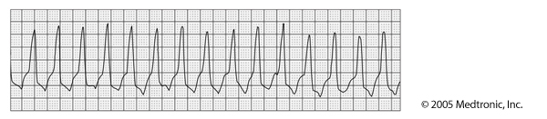

During ventricular tachycardia, there is In a normal EKG, there are regular signals
an extremely fast lower chamber rate. in both the upper and lower heart chambers.
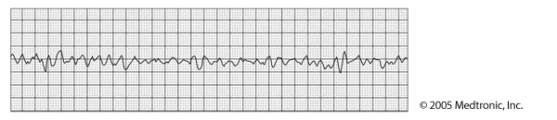

During ventricular fibrillation, there is In a normal EKG, there are regular signals
chaotic lower chamber activity. in both the upper and lower heart chambers.

Immediate treatment options for ventricular tachycardia/fibrillation include:
Defibrillation – in defibrillation, a device gives the heart an electric shock to restore a normal heartbeat. This treatment is mainly given in two ways: by an automatic external defibrillator (AED), or by an implantable cardioverter defibrillator (ICD). See additional safety information for ICDs.*

Automatic external defibrillator (AED) – AEDs are portable devices that measure the electrical activity of the heart and deliver defibrillation therapy if a fatal heart rhythm is detected. Most Emergency Response Teams carry and use AEDs. Thanks to recent studies showing their lifesaving role, AEDs are being placed in public gathering spots, such as government centers, airports, casinos, malls, stadiums, schools, and office buildings. AEDs do not work by themselves and can only be used by someone properly trained.

Antiarrhythmic medicines – these are referred to as rhythm-control medicines. They attempt to maintain or restore normal heart rhythm and are given through an IV by a physician or nurse. As with any medication, there are benefits and risks associated with use. Please discuss this with your doctor so the complete prescribing information can be provided.

Long-term treatment options for ventricular tachycardia/fibrillation include:
Implantable cardioverter defibrillator (ICD) – an ICD is the most effective way to treat ventricular arrhythmias. It is a pacemaker-like device that has been available since the mid-1980s. It is small –about the size of a pager – and is implanted under the skin in the upper chest and connected to the heart by special wires. The battery and computer circuits needed to correct an abnormal or fatal heart rhythm are contained in the device. Once it is implanted, an ICD works by itself and doesn’t require anyone to operate it. The ICD continuously monitors heart rhythm. If the ICD detects a ventricular arrhythmia, it will use small, painless electrical signals or a larger, sometimes painful shock to correct the heart rhythm. Most implantable defibrillators last 5 to 7 years before they need to be replaced.

Antiarrhythmic medicines – these are referred to as rhythm-control medicines. They attempt to maintain or restore normal heart rhythm. As with any medication, there are benefits and risks associated with use. Please discuss this with your doctor so the complete prescribing information can be provided.

Ablation – a procedure called radiofrequency ablation is recommended when heart rhythm cannot be controlled with medicines alone. During this procedure, small thin wires are threaded into your heart and electrical energy is used to remove or ablate the tissues causing heart rhythm problems. There are benefits and risks associated with this procedure. Please ask your doctor to provide you with this information.

Surgery – a surgical procedure has been successful in treating ventricular tachycardia. This procedure can require open-heart surgery and is most often done if other heart surgery is needed. As with any surgical procedure, there are benefits as well as risks. Talk to your doctor about this type of surgery to determine whether it is right for you and the associated risks.

* Safety Information
Additional Device Information
An implantable cardioverter defibrillator (ICD) system delivers therapies to treat patients with heart rhythm disorders or who are at significant risk of developing heart rhythm disorders. An ICD is placed inside your body and works automatically.

Risks associated with an ICD system implant include, but are not limited to, infection at the surgical site and/or sensitivity to the device material, failure to deliver therapy when it is needed, or receiving
extra therapy when it is not needed. After receiving an ICD system, you will have limitations with magnetic and electromagnetic radiation, electric or gas powered appliances, and tools with which you are allowed to be in contact.

Treatment with an ICD system is prescribed by your physician. This treatment is not for everyone. Please talk to your doctor to see if it is right for you. Your physician should discuss all potential benefits and risks with you. Although many patients benefit from the use of this treatment, results may vary.

Developed by the SCA Prevention Medical Advisory Team.
This material is intended to be educational. It is not intended to replace the information provided to you by your healthcare providers
and may not be directly applicable for your individual clinical circumstance.
Please refer to the manufacturers’ prescribing information and/or instructions for use for the indications, contraindications,
warnings, and precautions associated with the medications and devices referenced in these materials.

Sponsored by Medtronic, Inc.
May 2007
UC200705530 EN

