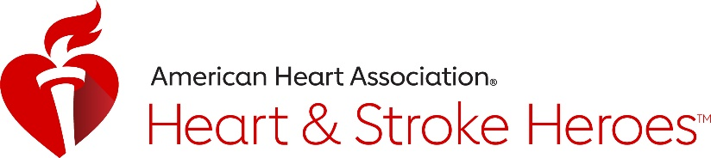

2019 New Jersey American Heart and Stroke Heroes
Frequently Asked Questions

Q. What is the New Jersey American Heart and Stroke Heroes Recognition program?
A. This program celebrates those who are working to strengthen the American Heart Association and American Stroke Association Chain of Survival.
- Individuals who recognize and respond in a stroke or cardiac emergency.
- People, organizations or businesses who increase the awareness, education or accessibility of CPR training and Automatic External Defibrillators (AEDs).
- People or groups who empower the public to recognize cardiac or stroke emergencies through education.

Q. What is the Chain of Survival?
A. The Chain of Survival refers to the links critical to improving the chances of survival and recovery for heart attack, stroke and other emergencies. The links are:
- Recognizing a heart attack, stroke or other cardiac emergency and activating the emergency response system, such as dialing 9-1-1
- Early CPR
- Rapid defibrillation
- Effective advanced life support
- Integrated post-cardiac arrest or stroke care.

Q. Who is the American Heart Association?
A. About the American Heart Association:
The American Heart Association is a leading force for a world of longer, healthier lives. With nearly a century of lifesaving work, the Dallas-based association is dedicated to ensuring equitable health for all. We are a trustworthy source empowering people to improve their heart health, brain health and well-being. We collaborate with numerous organizations and millions of volunteers to fund innovative research, advocate for stronger public health policies and share lifesaving resources and information. Connect with us on heart.org, Facebook, Twitter or by calling 1-800-AHA-USA1.

Q. Who is the American Stroke Association?
A. About the American Stroke Association:
Stroke is the No. 2 cause of death worldwide and a leading cause of disability. The American Stroke Association is a relentless force for a healthier world with fewer strokes. We team with millions of volunteers to prevent, treat and beat stroke by funding innovative research, fighting for stronger public health policies, and providing lifesaving tools and information. The Dallas-based association was created in 1998 as a division of the American Heart Association. To learn more or to get involved, call 1-888-4STROKE or visit strokeassociation.org. Follow us on Facebook and Twitter.

Q. Why is CPR/AED use important?
A. Cardiac arrest – an electrical malfunction in the heart that causes an irregular heartbeat (arrhythmia) and disrupts the flow of blood to the brain, lungs and other organs – is a leading cause of death. Each year, over 350,000 out-of-hospital cardiac arrests occur in the United States. If you are called on to give CPR in an emergency, you will most likely be trying to save the life of someone you love: a child, a spouse, a parent or a friend. Seventy percent of out-of-hospital cardiac arrests happen in homes.

- According to the American Heart Association, about 90 percent of people who suffer out-of-hospital cardiac arrests die. CPR, especially if performed in the first few minutes of cardiac arrest, can double or triple a person’s chance of survival.

Q. Why is recognizing a stroke important?
A. According to the American Stroke Association, approximately 795,000 Americans suffer a new or recurrent stroke each year. That means, on average, a stroke occurs every 40 seconds. Stroke is a medical emergency and immediate treatment may minimize the long-term effects of a stroke and prevent death. There may be treatment options available within 4.5 hours after the stroke has occurred.

Q. Are medical/EMS/police professionals eligible for the awards?
A. Yes, medical, EMS, fire fighters and police professionals are eligible if they responded to an emergency while OFF-DUTY.

Q. When will awardees be recognized?
A. Nominees selected to receive the New Jersey American Heart or Stroke Hero Award will be recognized at the state-wide celebration on Wednesday, September 25, 2019 at the Mercer Oaks Country Club in Princeton Junction, NJ at 6:00 pm. All selected awardees as well as nominators, will be notified prior to the event.

Q. Who can I reach out to with additional questions?
A. Reach out to Courtney Nelson, Senior Director of Community Impact at the American Heart Association and American Stroke Association at 609.223.3734 or courtney.nelson@heart.org.

Q. Where do I send in my completed nomination form?
A. Please return the nomination form by Monday, July 8, 2019 to:
American Heart Association | American Stroke Association
Attention: NJ Heart and Stroke Hero Awards
1 Union Street, Suite 301
Robbinsville, NJ 08691

Or email nominations to NewJersey@heart.org (Please use Heart and Stroke Hero in the subject line)

Additionally, nominations can also be submitted electronically by visiting www.heart.org/NJHeartStrokeHeroes and filling out the online nomination form.

