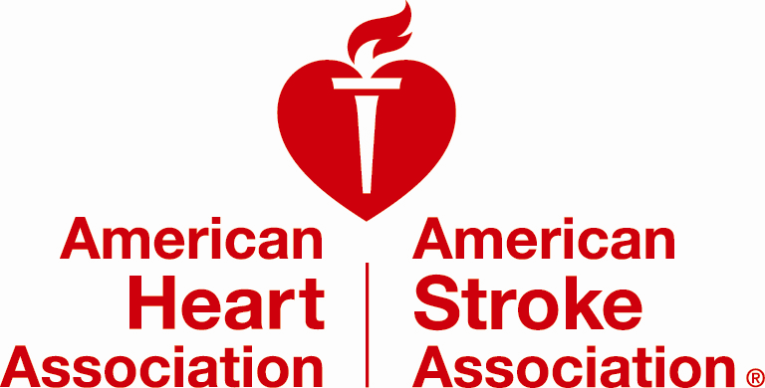

Quality Improvement Programs Permission Form

Hospital Name: _____________________________________________________________________________
(Print or type the legal name of your hospital)

Hospital Address: __________________________________________________________________________
(Print or type Street Address, City, State, Zip Code)

My hospital wishes to be recognized as:

__________________________________________________________________________________________
(Print or type the hospital name as it should appear in any recognition/promotional opportunity)

OPTIONAL: To be recognized by a different name for program specific recognition/promotional opportunities please complete any/all fields below that may apply, otherwise the hospital name provided above will be used.

Get With the Guidelines® Stroke: _______________________________________________________________
(Print or type the name of your hospital as it should appear in any Stroke program specific recognition/promotional opportunity)

Get With the Guidelines® Heart Failure: ___________________________________________________________
(Print or type the name of your hospital as it should appear in any Heart Failure specific recognition/promotional opportunity)

Get With the Guidelines® Resuscitation: __________________________________________________________
(Print or type the name of your hospital as it should appear in any Resuscitation specific recognition/promotional opportunity)

Get With the Guidelines®AFIB: __________________________________________________________
(Print or type the name of your hospital as it should appear in any Resuscitation specific recognition/promotional opportunity)

Mission: Lifeline®:____________________________________________________________________________
(Print or type the name of your hospital as it should appear in any Mission: Lifeline specific recognition/promotional opportunity)

This section must be completed:
□ WE AGREE □ WE DO NOT AGREE

to give American Heart Association/American Stroke Association (AHA/ASA) permission to use our name for:

- Recognition Events
- Advertisements (may include: AHA’s Circulation; ASA’s Stroke; US News & World Report)
- Conference banners/signage
- AHA website, digital media, mobile apps
- The Joint Commission (may include: Advanced Certification in Heart Failure, Primary Stroke Center and Comprehensive Stroke Center certifications)

In addition please select the additional opportunities you permit AHA/ASA to contact you regarding:

□ Quality program best practice case studies
□ Workshop/Webinars (presentations, posters)
□ Submitting a testimonial for use in our Quality program materials or on our Quality website
□ Serving as a mentor for new program hospitals

I have authority to sign on behalf of my hospital:

________________________________________ __________________________________________
Hospital Representative Printed Name ^{Title}

________________________________________ __________________________________________
Hospital Representative Signature ^{Date}

________________________________________ __________________________________________
^{Phone Number} ^{E-mail Address}

Authorization remains in effect until written notice is provided to AHA/ASA
(contact your local program director)
or program participation has terminated.

