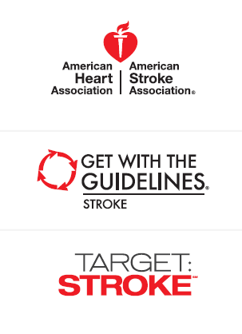
Goal 75% Target: Stroke Phase II aims to achieve DTN in 60 minutes in 75% or
more of acute ischemic stroke patients treated with IV tPA*

*Eligible Get With The Guidelines-Stroke/Target: Stroke acute
ischemic stroke patients treated between January 2016 to
December 2016

FEWER THAN 6 HOSPITALS PER STATE (too few to report) | State | Numerator/Denominator | Number of Hospitals Participating Per State
 | Alaska
 | Idaho
 | Montana
 | New Mexico
 | South Dakota
 | Vermont
 | Wyoming

25-49%  No Hospitals in this range | State | Numerator/Denominator | Number of Hospitals Participating Per State

50-74% | State | Numerator/Denominator | Number of Hospitals Participating Per State
 | Arkansas | 140/231 | 27
 | Connecticut | 202/286 | 16
 | Illinois | 873/1173 | 85
 | Indiana | 234/389 | 26
 | Iowa | 71/122 | 9
 | Maine | 67/91 | 7
 | Massachusetts | 492/779 | 62
 | Michigan | 562/792 | 38
 | Mississippi | 225/367 | 30
 | Nebraska | 50/78 | 7
 | New Hampshire | 43/73 | 8
 | North Dakota | 45/68 | 15
 | West Virginia | 128/185 | 8
 | Wisconsin | 314/420 | 48

75-100% | State | Numerator/Denominator | Number of Hospitals Participating Per State
 | Alabama | 168/224 | 18
 | Arizona | 633/770 | 26
 | California | 3235/3950 | 168
 | Colorado | 518/619 | 27
 | Delaware | 246/288 | 6
 | Florida | 2146/2572 | 105
 | Georgia | 895/1084 | 61
 | Hawaii | 137/178 | 11
 | Kansas | 315/383 | 17
 | Kentucky | 388/495 | 27
 | Louisiana | 333/414 | 18
 | Maryland | 512/649 | 40
 | Minnesota | 293/355 | 9
 | Missouri | 787/960 | 41
 | Nevada | 273/333 | 15
 | New Jersey | 832/1062 | 48
 | New York | 1868/2292 | 119
 | North Carolina | 871/1117 | 54
 | Ohio | 748/955 | 53
 | Oklahoma | 304/362 | 12
 | Oregon | 304/404 | 28
 | Pennsylvania | 1155/1526 | 95
 | Peurto Rico  (FL-PR Stroke Registry) | 1879/2226 | 74
 | Rhode Island | 124/151 | 8
 | South Carolina | 564/687 | 28
 | Tennessee | 836/992 | 33
 | Texas | 1906/2474 | 131
 | Utah | 164/213 | 12
 | Virginia | 422/522 | 30
 | Washington | 525/657 | 43

