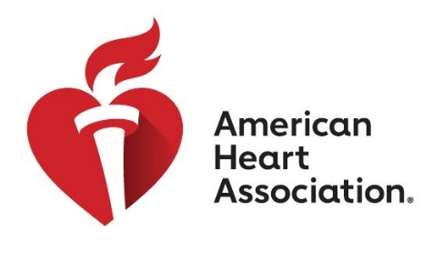

American Heart Association Young Professionals

American Heart Association Mission

To be a relentless force for a world of longer, healthier lives.

Young Professionals Mission
The mission of the Young Professionals (YP) is to engage and encourage its members to promote, provide leadership, and support the American Heart Association within each member's individual network and community. The YP members shall share their resources, time and talents and serve as representatives within their community to bring about awareness of heart disease and stroke as well as promoting activities, events, and volunteerism to members and non-members in the Pittsburgh community. The YP will put on at least two mission events and one fundraising event annually, in addition to supporting other events for the American Heart Association.

Benefits of Joining the AHA Young Professionals
- Network with experienced and emerging leaders in the Pittsburgh area
- Develop your professional leadership skills
- Gain a deeper knowledge and understanding of the nonprofit sector and philanthropy
- Give back to the community by supporting an organization doing vital work
- Play an active role in engaging other young people in the work of the AHA
- Meet other passionate young people and have fun!

Requirements on Young Professionals Members
Active members are expected to:
- Attend at least 4 of the 6 bimonthly group meetings
- Serve on two YP committee’s throughout the year; will meet on the “off” months leading up to specific event or activity
- Attend all events put on by the YP
- Engage and invite your friends and colleagues to support the AHA mission through AHA events and/or YP events
- Assist with recruitment efforts for YP either through personal recruitment or sharing the group through various channels
- Make a financial contribution to AHA (A minimum of $100 gift is suggested but not required)

