Alteplase Dosing and Administration Reference

- Obtain accurate patient weight in kilograms ________kg

- Calculate Total Alteplase dose (Max dose for ANY patient is 90 mg)
Total dose calculation:
0.9 mg X ________kg (weight) = ________ mg (total dose)

- From the total, calculate the bolus dose: 10% of total dose as bolus over 1 minute.
Bolus dose calculation:
0.10 X _______ mg (total dose) = _______ mg (bolus dose)

- Calculate the infusion dose: the remaining 90% of total dose over 1 hour, initiated immediately following bolus.
Infusion dose calculation:
0.90 X _______ mg (total dose) = _______ mg (infusion dose)
- Mix the Alteplase per manufacturer’s instructions (See steps below)
- After mixing Alteplase (1mg/mL), ensure excess is discarded before administration.

- Second RN should double check calculation and dosing before administration.

- When Alteplase infusion is complete, administer 50mL NS at Alteplase infusion rate to ensure all Alteplase is cleared from IV tubing.

Alteplase Reconstitution Reference
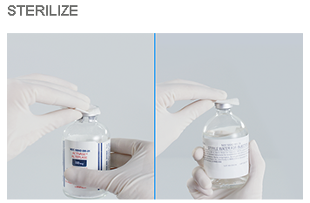
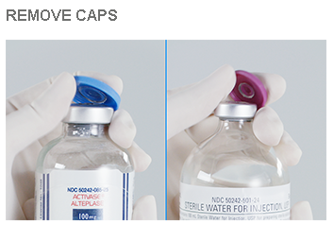
Step 1: Remove protective caps and swab the top of each vial with alcohol wipe to reduce the risk of contamination.

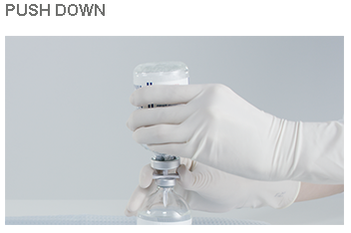
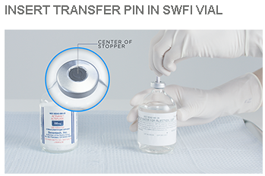
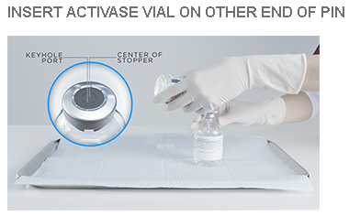
Step 2: Remove one of the protective caps from the transfer device and insert the piercing pin vertically into the center of the stopper of the Sterile Water for Injection (SWFI) vial, keeping the vial upright. Holding the Alteplase vial upside down, position it so that the center of the stopper is directly over the exposed pin of the transfer device. Push vial down onto the transfer device, ensuring that the piercing pin is inserted through the center of the Alteplase vial stopper.

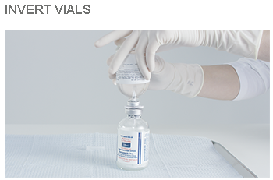
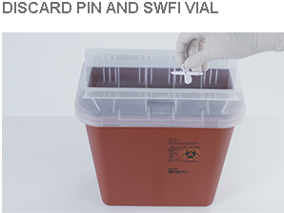
Step 3: Invert the 2 vials, so that the vial of Alteplase is on the bottom (upright) and the vial of SWFI is upside down. Allow the entire contents of the vial of SWFI to flow down through the transfer device into the vial containing Alteplase. Approximately 0.5 mL of SWFI will remain in the diluent vial. Remove the transfer device and the empty SWFI vial from the Alteplase vial. Safely discard both the transfer device and the empty diluent vial.

Step 4: Mix the solution with a gentle swirl. DO NOT SHAKE. Slight foaming of the solution is normal. Let the solution stand undisturbed for several minutes to allow any large bubbles to dissipate. This preparation will result in a colorless to pale yellow transparent solution containing Alteplase at a concentration of 1mg/mL. Visually inspect Alteplase solution for particulate matter and discoloration before administration. May be used within 8 hours of reconstitution when stored between 2-8°C.

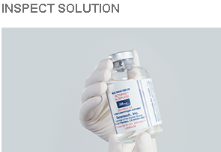
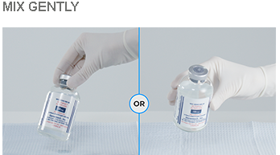
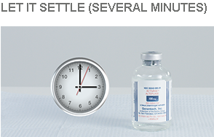

*Genentech will provide credit/replacement for mixed and unused or expired Alteplase. Contact Genentech Customer Service @ (800) 551-2231

