Tenecteplase for STROKE
(3 checks in 30 seconds) = Time OUT prior to dose being given
- Right Patient
- Right Medication
- Right Dose
- MAX dose of Tenecteplase is 25 mg (5 mL of reconstituted solution)
- Tenecteplase can precipitate if giving in an IV line with dextrose
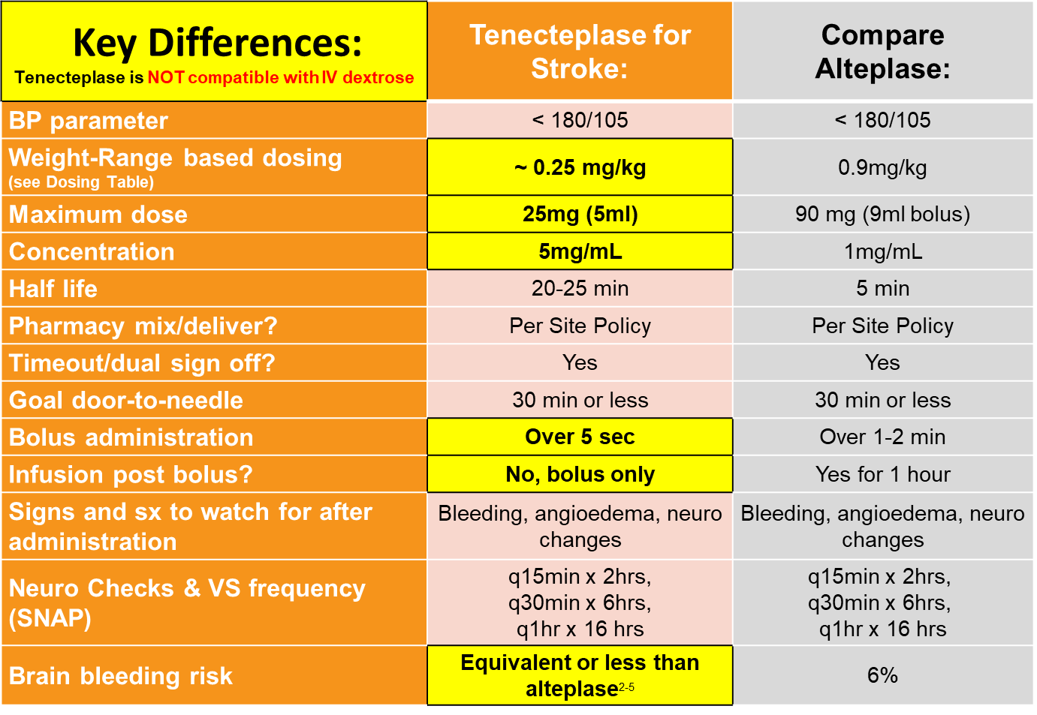
- It is recommended to flush before and after dose with NS
45
45

Tenecteplase Reconstitution:
- Use 10 mL syringe with blunt fill needle (suppled in kit) to withdraw 10 mL Sterile water
- Inject 10 mL sterile water into the Tenecteplase vial
- Gently swirl the vial (DO NOT SHAKE)
- Inspect vial for clarity and absence of particulate matter
- Calculate dose according to patients’ actual weight using the weight-range dosing table. (Dose should be about 0.25 mg/Kg)
- Use 5 mL syringe to withdraw dose
- MAX dose is 25 mg – There should always be waste
Tenecteplase Dosing
Acute Ischemic Stroke
Concentration: 5 mg/mL
Dose: 0.25 mg/kg (rounded to nearest mg)
MAX DOSE: 25mg
Patient's Actual Weight in KG | Dose (mg) | Dose (mL)  (*round to nearest 0.2 mL)
26 - 29.9 | 7 | 1.4
30 - 33.9 | 8 | 1.6
34 - 37.9 | 9 | 1.8
38 - 41.9 | 10 | 2
42 - 45.9 | 11 | 2.2
46 - 49.9 | 12 | 2.4
50 - 53.9 | 13 | 2.6
54 - 57.9 | 14 | 2.8
58 - 61.9 | 15 | 3
62 - 65.9 | 16 | 3.2
66 - 69.9 | 17 | 3.4
70 - 73.9 | 18 | 3.6
74 - 77.9 | 19 | 3.8
78 - 81.9 | 20 | 4
82 - 85.9 | 21 | 4.2
86 - 89.9 | 22 | 4.4
90 - 93.9 | 23 | 4.6
94 - 97.9 | 24 | 4.8
98 kg or greater | 25 | 5

