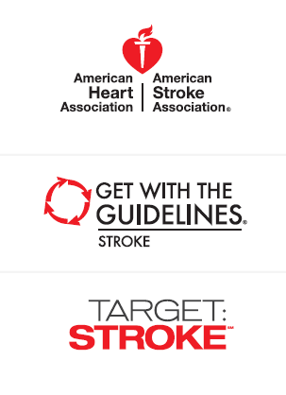
Goal 50% DTN in 60 minutes or less
Eligible Get With The Guidelines-Stroke/Target: Stroke
Acute ischemic stroke patients January 2012 to December 2012

State, numerator/denominator, number of hospitals participating per
state

0-24% | State | Numerator/Denominator | Number of Hospitals Participating Per State
 | Alaska*
 | Idaho*
 | Montana*
 | New Mexico*
 | Nebraska | 12/57 | 12
 | Puerto Rico*
 | South Dakota*
 | Vermont*
 | Wyoming*
 | *fewer than 6 hospitals, too few to report

25-49% | State | Numerator/Denominator | Number of Hospitals Participating Per State
 | Alabama | 45/133 | 28
 | Arizona | 255/452 | 25
 | Arkansas | 21/64 | 36
 | California | 766/1755 | 131
 | Connecticut | 102/235 | 21
 | Delaware | 21/66 | 6
 | Florida | 467/1294 | 127
 | Georgia | 270/627 | 55
 | Hawaii | 41/100 | 11
 | Illinois | 170/507 | 71
 | Indiana | 61/232 | 30
 | Iowa | 36/93 | 14
 | Kentucky | 61/137 | 22
 | Maine | 22/48 | 7
 | Maryland | 130/408 | 37
 | Massachusetts | 214/516 | 71
 | Michigan | 142/471 | 48
 | Mississippi | 45/112 | 11
 | Nevada | 48/137 | 12
 | New Hampshire | 10/37 | 8
 | New Jersey | 234/517 | 45
 | New York | 667/1428 | 112
 | North Carolina | 264/536 | 27
 | North Dakota | 6/23 | 9
 | Ohio | 149/389 | 45
 | Oregon | 78/210 | 26
 | Pennsylvania | 246/862 | 77
 | Rhode Island | 57/135 | 9
 | South Carolina | 90/258 | 23
 | Tennessee | 41/126 | 12
 | Texas | 490/1147 | 96
 | Virginia | 87/241 | 37
 | Washington | 137/353 | 45
 | Wisconsin | 63/233 | 45

50-74% | State | Numerator/Denominator | Number of Hospitals Participating Per State
 | Colorado | 150/243 | 29
 | Kansas | 83/164 | 12
 | Louisiana | 131/256 | 20
 | Minnesota | 131/244 | 21
 | Missouri | 259/477 | 27
 | Oklahoma | 70/128 | 8
 | Utah | 106/171 | 17
 | West Virginia | 47/86 | 7

75-100% | State | Numerator/Denominator | Number of Hospitals Participating Per State
 | -None-

